Write Up Document

Approach:

1. Creation of a set of Process using multi threading which communicate with the following data.

Process Name:
Process Cost:
Process Neighbors:

2. Based on the each nodes communication a graph like below can be constructed.

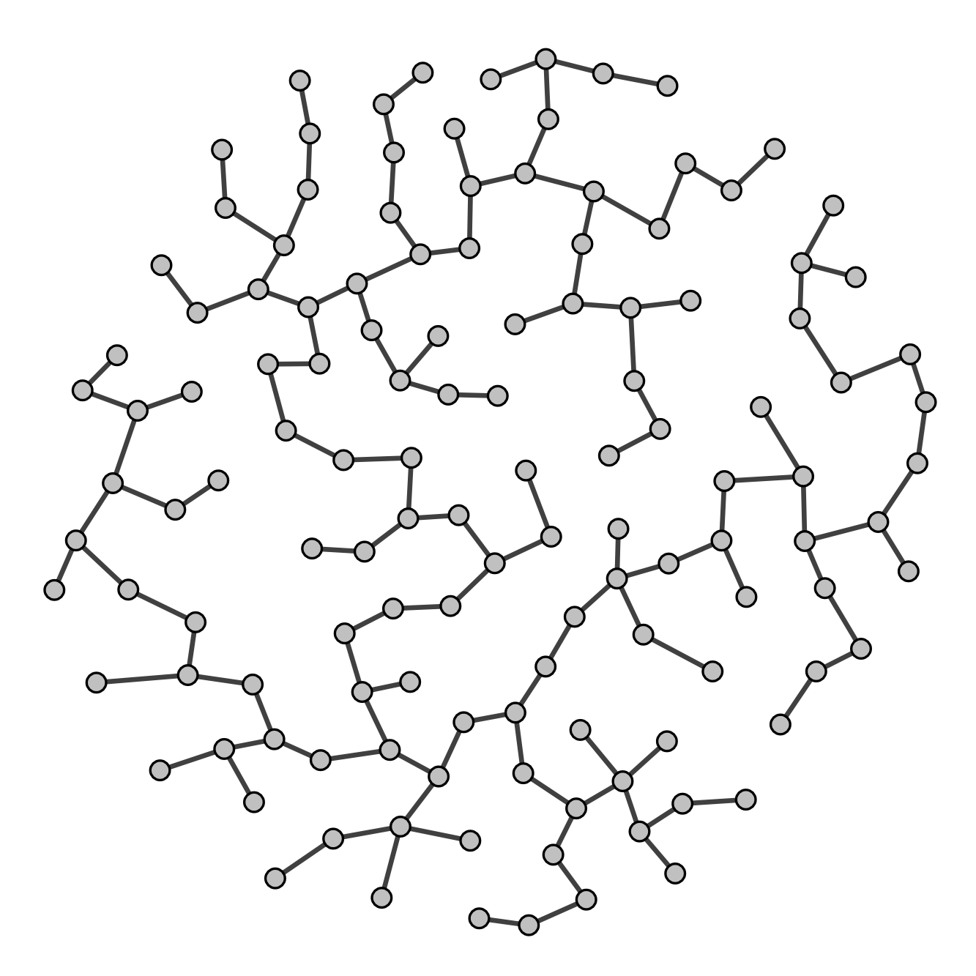

Design:

1. The graph would be represented using an Adjacency List. The size of array would be equal to no of nodes in the network. From the process output this list can be constructed for each node.
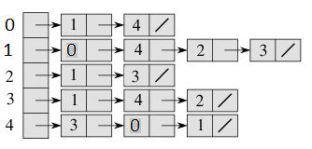

2. Network Reconfiguration when a process dies out then we will bypass the link in the adjacency list to the next available node.

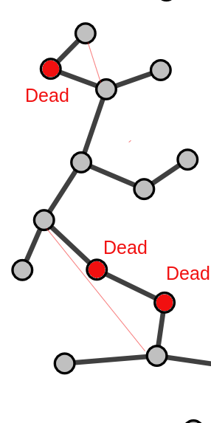

3. Network reconfiguration when a new node starts up in the middle of network. In the adjacency list we will point the head of the previous node to the newly started node and the tail of newly started node to the next communicating node.

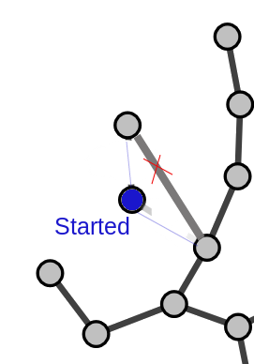

When there is no next available node , the tail would be set to null.

4. Shortest path between two vertices's , can be calculated using .For a general weighted graph, we can calculate single source shortest distances using Bellman–Ford Algorithm as In this network we cannot guarantee the non-existence of negative weights.

5. To find the minimum spanning tree the following logic can be used

Spanning tree means all vertices's must be connected. So the two disjoint subsets (discussed above) of vertices's must be connected to make a Spanning Tree. And they must be connected with the minimum weight edge to make it a Minimum Spanning Tree.

Unit Testing:

TEST CASE | EXPECTED OUTPUT
1. Make a node to die in the tree. | Network should be reconfigured with out any breaks.
2. Make multiple nodes die out. | Network must be reconfigured with links established to next possible alive node in the shortest path.
3. More number of process trying to communicate to a single node. | Receiving node must be stable and should be able to balance the node.

